Oru Replenish user guide
Inventory purchasing for Shopify merchants · 7 November 2026
Use this guide to configure demand assumptions, review stock needs, and prepare supplier purchases. Review every suggested purchase before ordering; estimates depend on the values you enter.

1 Review inventory
Open Oru Replenish from Shopify admin after installation. Overview shows current inventory, estimated stock coverage, incoming purchases, and reorder decisions. The pictures in this guide use sample data.
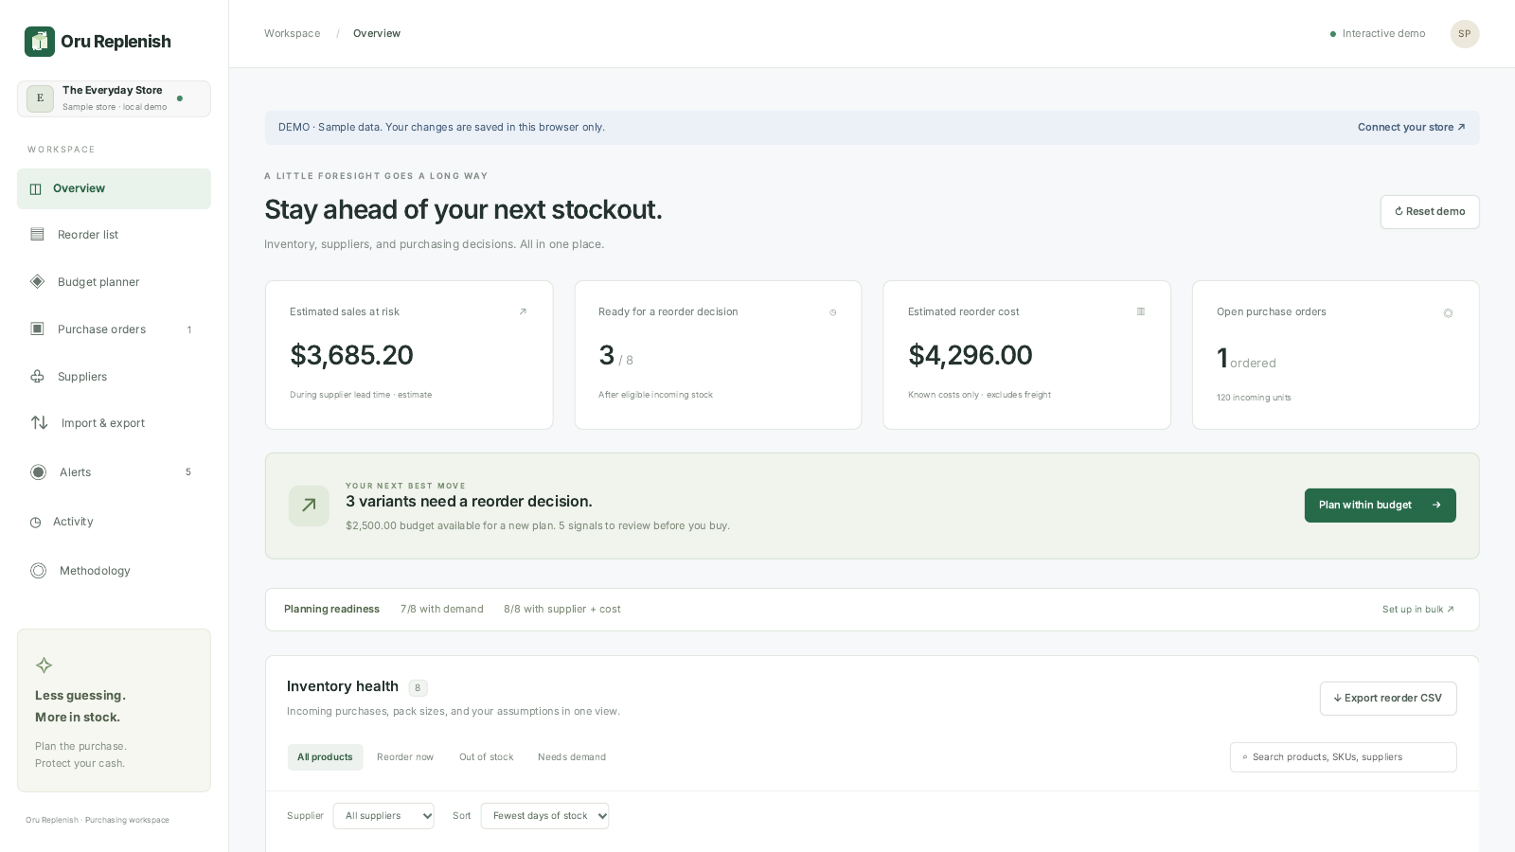
Sample workspace · illustrative data
Start with suppliers and product demand settings before relying on the suggestions. Inventory is read across Shopify locations; planning rules apply to a variant across those locations. Free supports up to 50 active variants. Pro is planned at 5,000 variants. Installation and paid plans are subject to launch availability.

2 Add suppliers
Open Suppliers and choose Add supplier. Save the supplier name, contact details, default lead time, minimum merchandise order value, freight per order, and notes. Saving a contact does not send a message.
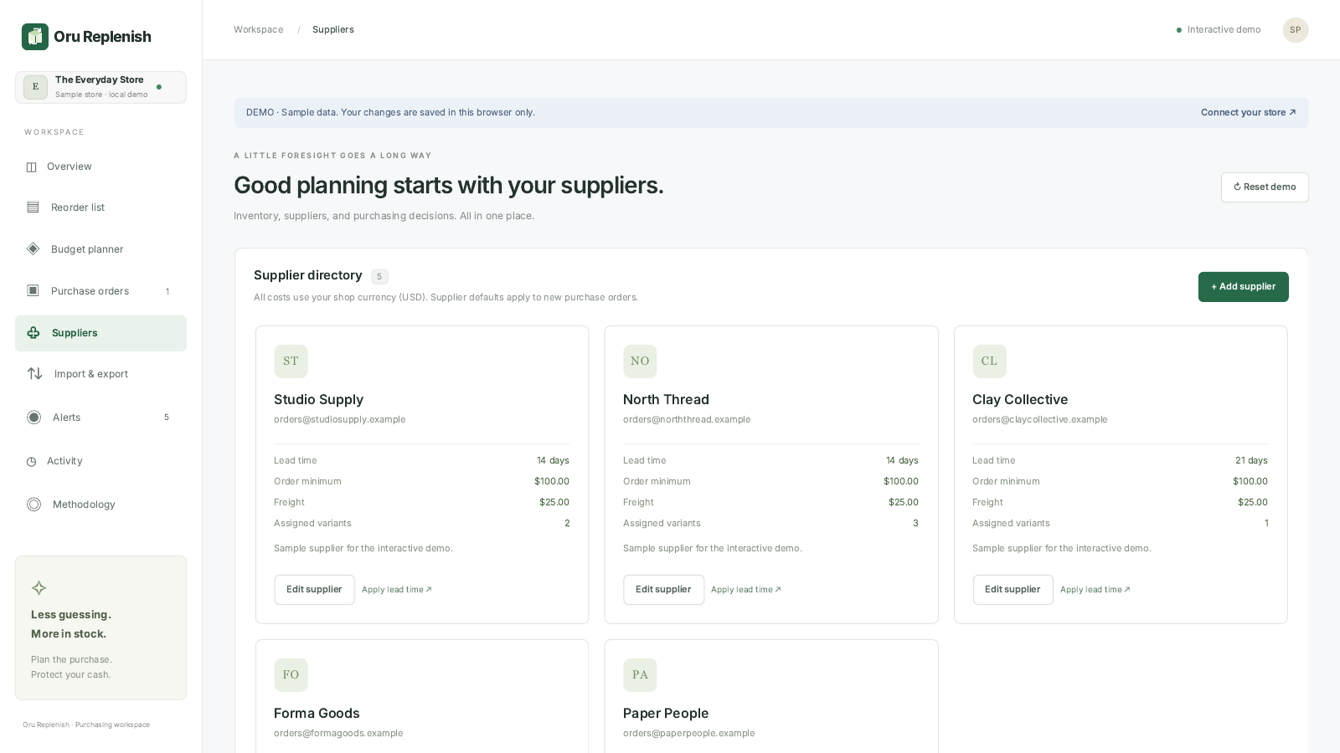
Sample workspace · illustrative data
Assign suppliers to individual product rules. Apply lead time copies the supplier default to assigned rules; review these values when suppliers change. Free allows 3 suppliers; planned Pro allows 200.

3 Set demand and purchasing rules
Open Reorder list and choose Plan beside a product. Enter expected units sold per day, lead time, safety buffer, target coverage, unit cost, minimum order units, pack size, and supplier.
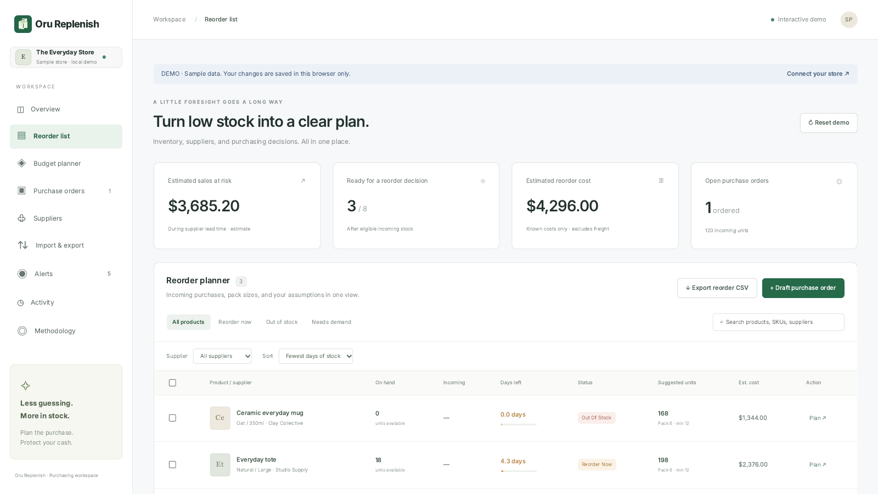
Sample workspace · illustrative data
Demand is entered manually and does not come from order history. Zero demand produces no demand forecast. Supplier assignment and a known unit cost are needed for the budget shortlist. Pack rounding and minimum quantities can increase a recommendation.

4 Plan purchases within a budget
Open Budget planner, enter the amount available for new purchases, and choose Update budget. Review the suggested supplier orders and their freight before creating drafts.
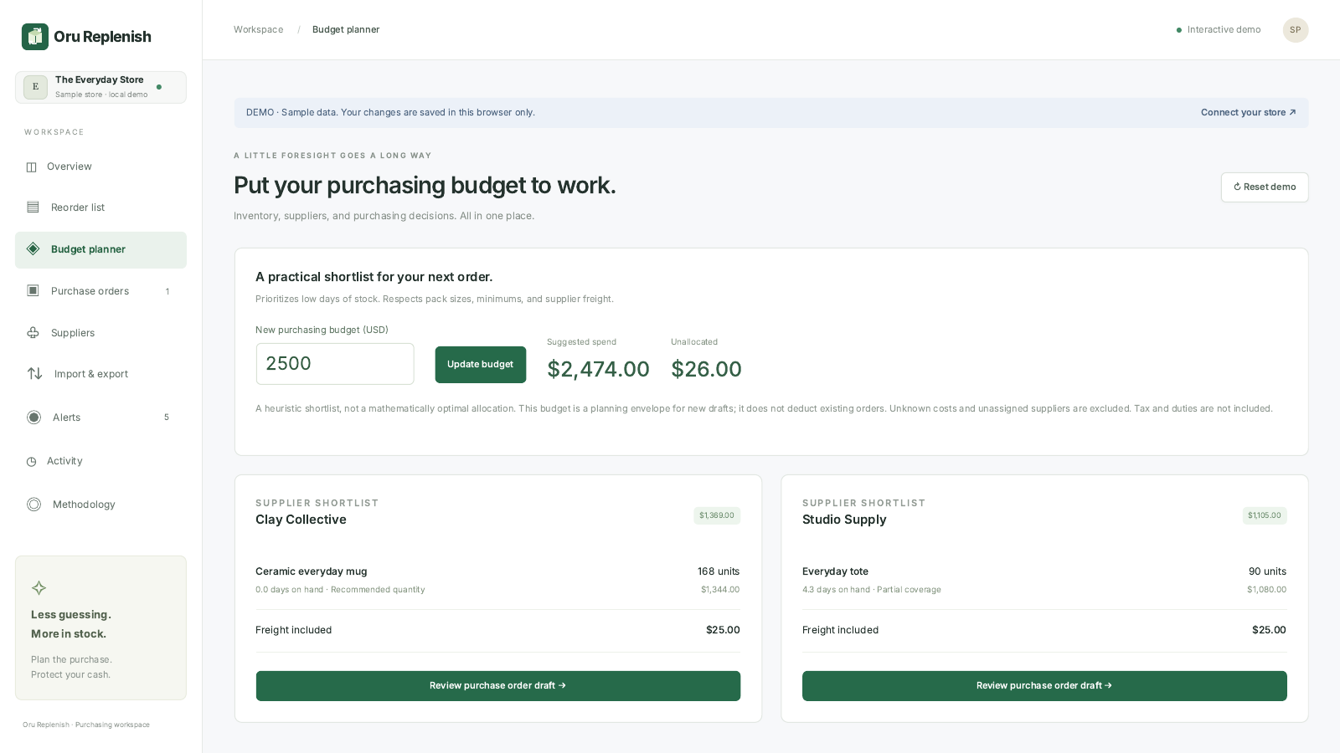
Sample workspace · illustrative data
The planner prioritizes urgent stock and fits whole packs while respecting minimum order values. It is a heuristic, not a mathematically optimal allocation. Taxes and duties are excluded. Existing purchase orders are not deducted from this new purchasing budget.

5 Track purchase orders
Create a draft from the supplier shortlist or Purchase orders. Check the quantity, cost, and expected delivery date, then export the order and arrange the purchase with your supplier. Mark it placed after arranging the purchase externally.
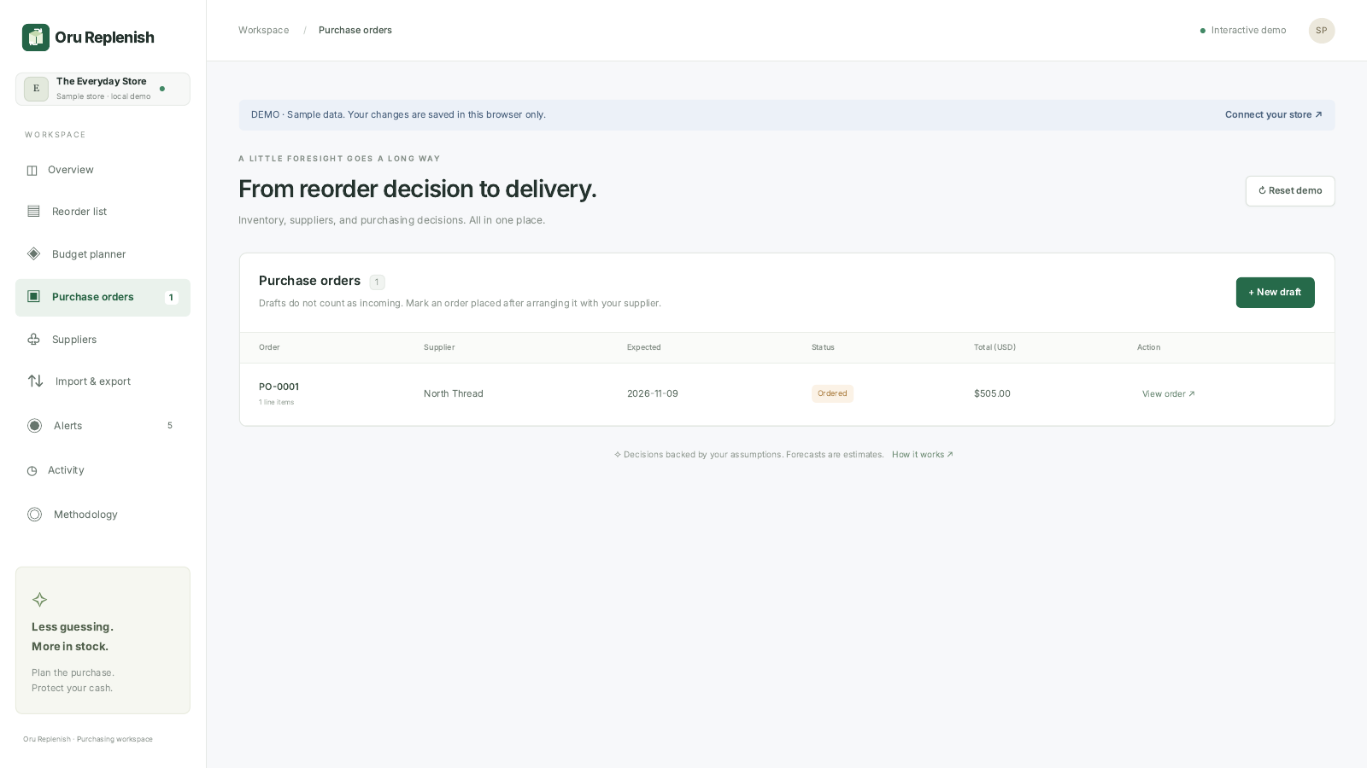
Sample workspace · illustrative data
Only eligible placed orders with non-overdue dates inside the planning horizon reduce reorder suggestions. When the full order arrives, receive the stock directly in Shopify, refresh inventory here, and close the purchase order after confirming Shopify reflects all units. Partial receiving is not supported. Oru Replenish does not change inventory, email suppliers, or make payments.

6 Import settings and export records
Open Import and export and download the planning CSV template. Keep its headings and variant IDs unchanged, enter your planning values, and select the file to preview validation. Apply only after reviewing every row.
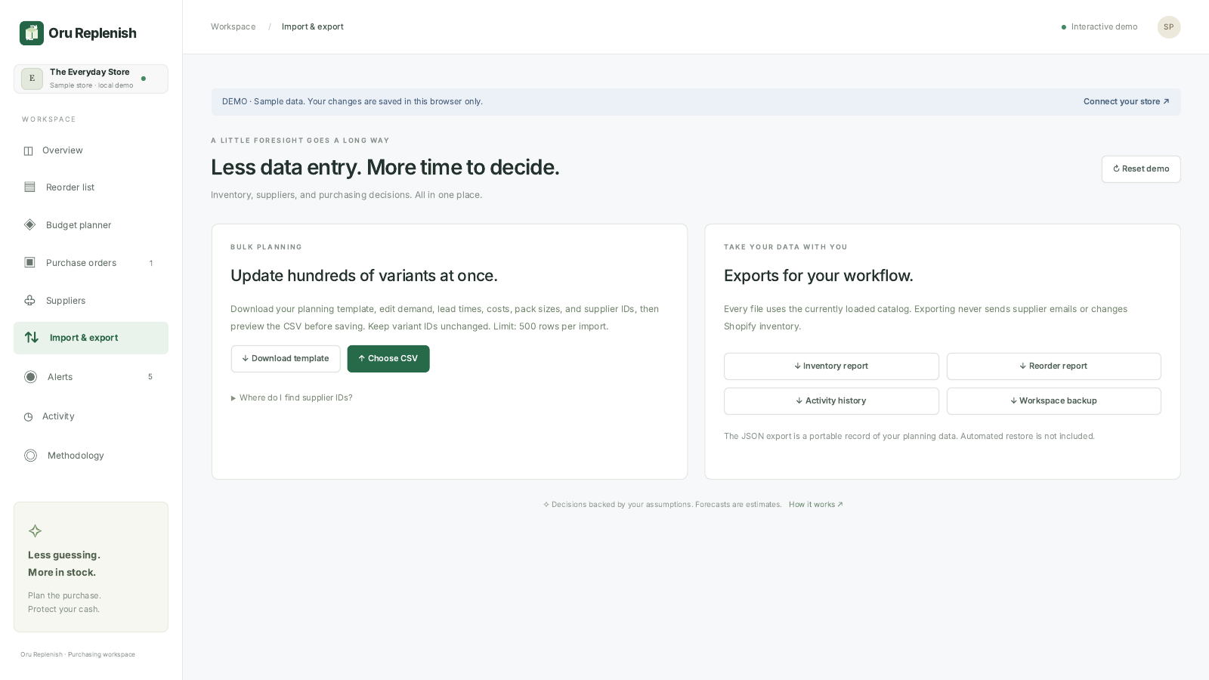
Sample workspace · illustrative data
Imports are limited to 500 rows and 1 MB. Invalid, duplicate, or unknown variants block the entire batch. Export inventory, reorder lists, individual purchase orders, activity, or a JSON workspace record for your own files. The JSON export is a record, not an automatic restore workflow.

Alerts and support
Alerts are shown inside the app. Activity retains the latest 300 workspace changes in UTC. Sales at risk estimates gross sales exposure during lead time; it is not measured lost revenue or profit. See Methodology for formulas. Help: https://replenish.orustudio.com/help · Support: naimkst@gmail.com

